# **Innobyte Services**



# **Web Developer Internship**

**INTERNSHIP PROJECT REPORT**

**On**

***Redesign of King Sukh Guest House Website***

**Project ID:** *78GRB6TY2D*

**Submitted By:** Siddhi Ananda Thorat

**Internship Role:** Web Developer Intern

**Submitted To:**

**Company:** Innobyte Services

**Supervisor:** Sonali Agarwal

**Designation:** SR HR Director

**ACKNOWLEDGEMENT**

I would like to express my sincere gratitude to **Innobyte Services** for giving me the opportunity to work as a **Web Developer Intern** on the project titled **“Redesign of King Sukh Guest House Website.”**

My heartfelt thanks to Sonali Agarwal for providing valuable guidance, feedback, and support throughout the internship. The experience allowed me to apply my technical skills in real-world scenarios, strengthen my understanding of web technologies, and gain hands-on experience in responsive design, front-end optimization, and professional project workflow.

I would also like to thank all the team members at **Innobyte Services** for their cooperation and encouragement during my internship period.

This internship has been an incredible learning experience and has enhanced my confidence and expertise in modern web development.

Siddhi Thorat

**ABSTRACT**

The *King Sukh Guest House Website Redesign* project aims to enhance the digital presence of King Sukh Guest House by developing a modern, responsive, and visually appealing website. The primary goal was to improve user experience, accessibility, and overall interface aesthetics through a complete front-end revamp. The website was built using React.js, Vite, and Tailwind CSS, ensuring fast performance, modular design, and responsiveness across all devices. The redesigned interface features an intuitive layout, dynamic room and gallery sections, and an engaging presentation of services to attract more visitors and potential customers. This project reflects the implementation of industry-level design principles and front-end development standards to deliver a professional and user-friendly web experience.

**INTRODUCTION**

The *King Sukh Guest House Website Redesign* project focuses on transforming the existing static website into a dynamic, responsive, and visually engaging platform. The main objective of this project is to improve the overall digital experience for users by implementing a clean design, faster loading speed, and enhanced accessibility.

King Sukh Guest House, known for its comfortable stay and beautiful surroundings, required a modern web presence to effectively showcase its rooms, services, and amenities to potential guests. The redesigned website not only highlights the guest house’s features but also provides a smooth navigation experience and consistent performance across devices.

The project was developed using React.js, Vite, and Tailwind CSS, ensuring scalability, modularity, and optimized performance. The new layout focuses on usability and aesthetics, incorporating interactive sections such as room listings, service highlights, and image galleries.

Through this redesign, the website now aligns with modern web standards and fulfils the goal of offering a seamless digital experience to both new and returning visitors.

**OBJECTIVES**

The *King Sukh Guest House Website Redesign* project was developed with the following key objectives:

1. **Enhance User Experience (UX):**  
   Create a smooth, visually appealing, and responsive interface that offers effortless navigation for visitors.
2. **Modernize the UI Design:**  
   Redesign the website with a clean, contemporary layout using React.js and Tailwind CSS to improve aesthetic appeal.
3. **Improve Performance and Responsiveness:**  
   Optimize the website for faster load times and ensure compatibility across all devices and screen sizes.
4. **Highlight Rooms and Services:**  
   Present the guest house’s rooms, amenities, and services in an organized and engaging manner to attract potential customers.
5. **Ensure Scalability and Maintainability:**  
   Build a modular and component-based front-end structure using React.js for easier future updates and maintenance.
6. **Enhance Visual Storytelling:**  
   Integrate high-quality visuals and interactive elements to better represent the comfort and atmosphere of the guest house.
7. **Boost Online Visibility:**  
   Lay the foundation for improved search engine performance and future digital marketing integrations.

**SCOPE OF THE PROJECT**

The *King Sukh Guest House Website Redesign* project focuses on transforming an outdated and static website into a modern, responsive, and user-friendly platform. The new website aims to enhance the overall online presence of the guest house and provide visitors with an engaging digital experience.

1. **Modern Frontend Development:**  
   The website is built using **React.js** and **Tailwind CSS** to achieve a clean, attractive, and efficient user interface.
2. **Responsive Design:**  
   The layout automatically adapts to different devices such as desktops, tablets, and smartphones, ensuring accessibility for all users.
3. **Service and Room Display:**  
   The site effectively showcases rooms, services, and amenities offered by King Sukh Guest House, helping visitors make informed choices.
4. **Navigation and User Flow:**  
   Intuitive navigation and logical page structure make it easy for users to explore information and find relevant details quickly.
5. **Optimized Performance:**  
   The website is optimized for faster loading times, improved usability, and smooth interactions.
6. **Maintainability and Scalability:**  
   The modular structure allows easy updates, feature additions, and integration of new technologies in the future.

**SYSTEM REQUIREMENTS**

1. **Hardware Requirements:**

|  |  |  |
| --- | --- | --- |
| Component | Minimum Specification | Recommended Specification |
| Processor | Intel Core i3 or equivalent | Intel Core i5/i7 or higher |
| RAM | 4 GB | 8 GB or more |
| Storage | 500 MB free space | 1 GB free space |
| Display | 1366×768 resolution | Full HD (1920×1080) or higher |

1. **Software Requirements:**

|  |  |
| --- | --- |
| Component | Specification |
| Operating System | Windows 10 / 11, macOS, or Linux |
| Frontend Framework | React.js |
| Styling Framework | Tailwind CSS and Bootstrap |
| IDE / Code Editor | Visual Studio Code |
| Version Control | Git & GitHub |
| Package Manager | Node.js with npm or yarn |
| Browser | Google Chrome / Microsoft Edge (latest version) |

1. **Development Tools:**

* **VS Code Extensions:**
* Prettier – Code Formatter
* ES7+ React/Redux/React-Native snippets
* Tailwind CSS IntelliSense
* **Command Line Tools:**
* Node.js (for local development server)
* Git (for version control and project deployment)

**OUTPUTS**

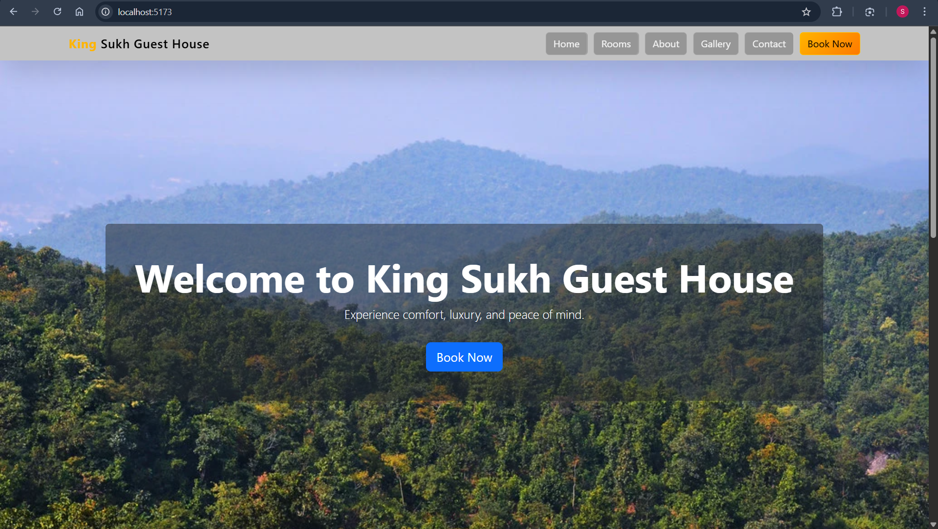

**Figure 1: Hero Section**

